

CIVE202 – Drinking Water Project #2 Written Report
Brock Hoover, Fatima Davila, Mehgan Paulino, Owen Betts
May 7, 2026

Introduction: 3
Data Filtering before being inserted into Python: 3
Total Coliform Rule and Revised Total Coliform Rule meaning: 3
Statement regarding bias in the code: 3
Methods: 4
Setting up code: 4
Defining Functions: 5
Plot showing total violations for all states: 5
Plot showing total violations for all states: 6
Results: 6
General Trend/Summary: 6
Nebraska 7
California 8
Tennessee 8
Connecticut 9
Arkansas 10
Conclusion: 11
References: 11

Data Filtering before being inserted into Python: 3
Total Coliform Rule and Revised Total Coliform Rule meaning: 3
Statement regarding bias in the code: 3
Methods: 4
Setting up code: 4
Defining Functions: 5
Plot showing total violations for all states: 5
Plot showing total violations for all states: 6
Results: 6
General Trend/Summary: 6
Nebraska 7
California 8
Tennessee 8
Connecticut 9
Arkansas 10
Conclusion: 11
References: 11
Introduction: 3
Data Filtering before being inserted into Python: 3
Total Coliform Rule and Revised Total Coliform Rule meaning: 3
Statement regarding bias in the code: 3
Methods: 4
Setting up code: 4
Defining Functions: 5
Plot showing total violations for all states: 5
Plot showing total violations for all states: 6
Results: 6
General Trend/Summary: 6
Nebraska 7
California 8
Tennessee 8
Connecticut 9
Arkansas 10
Conclusion: 11
References: 11

Data Filtering before being inserted into Python: 3
Total Coliform Rule and Revised Total Coliform Rule meaning: 3
Statement regarding bias in the code: 3
Methods: 4
Setting up code: 4
Defining Functions: 5
Plot showing total violations for all states: 5
Plot showing total violations for all states: 6
Results: 6
General Trend/Summary: 6
Nebraska 7
California 8
Tennessee 8
Connecticut 9
Arkansas 10
Conclusion: 11
References: 11

Introduction:
In this project, our project team was tasked by a research team at UMass Amherst to get a representative understanding of Total Coliform Rule (TCR) violations in the United States, and to pick five different states in five different EPA regions to get a representative understanding of TCR violations in the U.S. The five states that our project team picked were Nebraska, California, Tennessee, Connecticut, and Arkansas. Our project team aimed to observe what years these violations happened, and the frequency in those years of big systems vs small systems. The data was gathered from the SDWIS database

Data Filtering before being inserted into Python:
Before the data could be imported into python, some manual filtering was done in Microsoft excel to correctly set up the .csv file. The data for each individual state was downloaded from the SDWIS website, and was then filtered to only include TCR and Revised TCR violations, and then copy and pasted into a csv file that included the violation data for the five states on the dataset. Our dataset we analyzed also only included 2025Q4 data, as the 2026Q1 data was not finalized when the project was started.

Total Coliform Rule and Revised Total Coliform Rule meaning:
According to an article titled “Revised Total Coliform Rule and Total Coliform Rule” by the EPA (2026), Total Coliforms are a group of bacteria that while not harmful to humans themselves, can indicate an issue with other pathogens being present in drinking water and are used to determine if the distribution and treatment system are adequate. The same article also mentions the revised total coliform rule, which was implemented in April 1st , 2016 and contains some changes to the original TCR rule to improve public health protection. Both rules are useful for our data analysis, and violations of both are considered in the dataset.

Statement regarding bias in the code:
In our code, only five states are analyzed, and the states were chosen based on our project team’s familiarity with each state. While some of this is alleviated by the requirement to choose states from five different regions, this neglects some regions, and neglects certain states in certain regions. Other project teams conducting similar research might find differing results due to our bias in our results.

Methods:

Setting up code:
In our python code, multiple packages were used, and they are all imported in the second code block (the first one is used for the initial plotly install.). The packages used are Pandas, MatPlotLib, Seaborn, and Plotly. Pandas is used primarily for functions related to data processing, MatPlotLib is used for creating histograms, seaborn is used for aesthetics, and Plotly is used for most of the plotting in the code. A general style for the seaborn plots is set, and the dataset is then read and imported into the code using the pandas .read_csv function. Figure 1 shows the initial code blocks to set up the project.
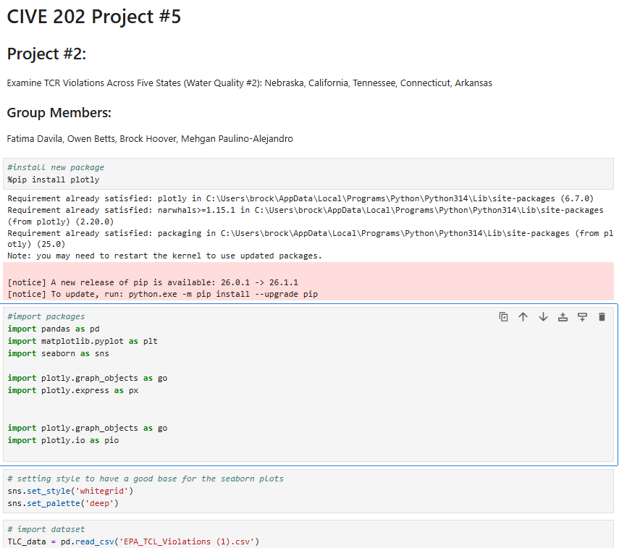
Figure 1, code blocks in charge of importing packages, setting a style, and importing the dataset

Defining Functions:
For this project, we were tasked to find the difference between big water systems and small water systems, which our group interpreted as systems in large population areas vs systems in small population areas, our group chose a number of 500 because it split the data in a way that outlined the data well. Two functions were made, with one categorizing systems as a small_system and one categorizing systems as a large_system. These were done by using the data read from the .read_csv function and looking at the population served count to determine what is a small system and what is a large system. The code block regarding this can be seen in Figure 2.
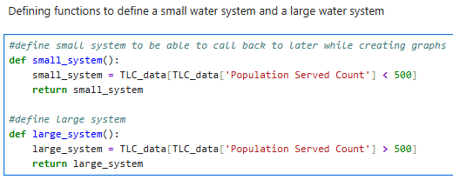
Figure 2, code block defining functions

Plot showing total violations for all states:
The next code block shows the total violation reports for all five states that we analyzed. The code block’s first line of code is to make sure plotly renders the interactive charts directly in the Jupyter notebook. The next lines of code make sure to convert the data to the correct data types, and uses the errors=’coerce’ line to make errors with the data values convert to NaN cells instead of causing errors. .dt.year is then used to create a new column with the four digit year, as all of the data in the csv is two digit year values, and the .dropna function is used to filter out rows that have missing values for population or for year.
The go.Figure() function is then used to start building the plot, and the .add_trace() function is then used to add both the large and small system functions to the plot, .update_layout() is then used to set the plot title, axis titles, and the templates, and then fig.show() is used at the end of the code to display the plot. The code block is shown in Figure 3.
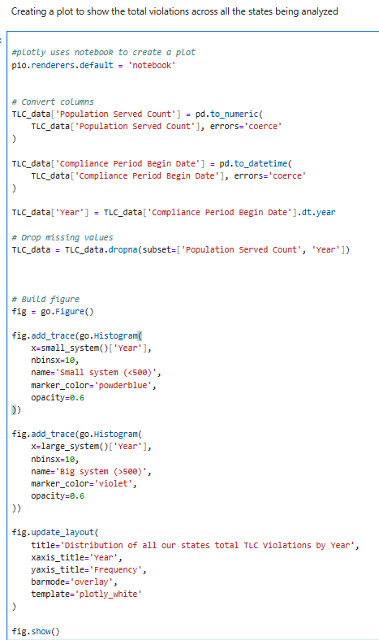
Figure 3, Code block to create plot of total violations across all states being analyzed

Plot showing total violations for all states:
For all the states, the code blocks were similar, so they are not going to be fully documented in this report but can be seen in the annotated code document. The main difference was redefining the variable as the state data, and using .copy() to prevent issues with overwriting, an example of this for Nebraska can be found in Figure 4.
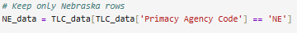
Figure 4, Code to only keep specific rows of a state

Results:

General Trend/Summary:
For the difference in frequency by year for small systems and large systems regarding TCR violations, for the five states analyzed by our project team, we found that large systems show up significantly less on our dataset, but have a more consistent year to year variance of issues than the small systems, for most of the states, the maximum amount of violations was observed between 2000 and 2010 and gradually tapers off before and after those years. The Figure of the TCR violations can be seen in Figure 5.
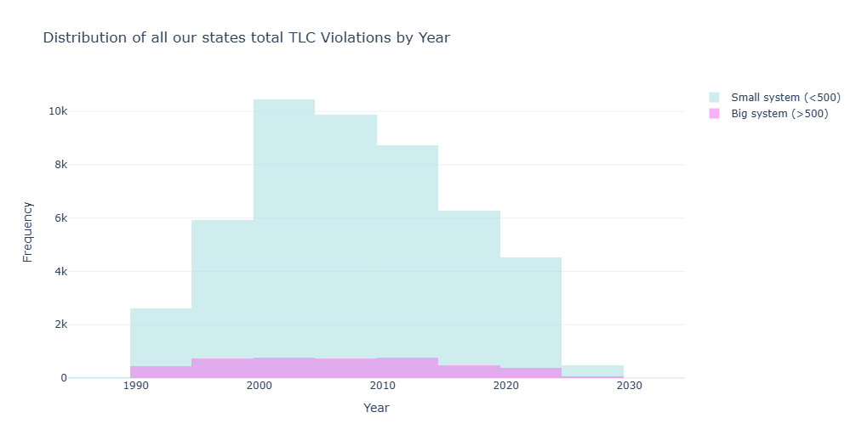
Figure 5, Distribution of all states TCR violations by year

Nebraska
Nebraska for this project was chosen as the representative state from EPA Region 7, between the years of 1995 and 1999 is when the majority of small system violations are observed, but it has declined every five year span since then. Large system violations are fairly consistent from 1994 to 2014, but have declined significantly in the last few years. Nebraska is a very rural state, and the highest number of small system violations in a range was observed from 1995 to 1999 with 1,458 total. The highest number of large system violations in a year was observed from 2010 to 2014 with 178 total. The distribution of Nebraska Systems by year can be seen in Figure 6
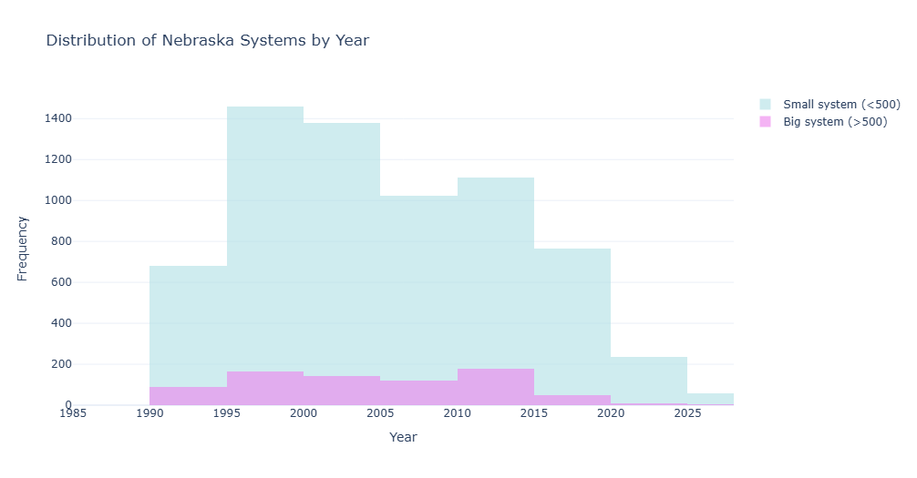
Figure 6, Distribution of Nebraska Systems by Year

California
California for this project was chosen as the representative state from EPA Region 9, and Figure 7 shows the distribution of the systems in California by year. California has the highest observed five year frequency of small system violations in all the states observed by our project team with 5,396 violations in small systems from 2005 to 2009. Large system violations has its max five year violation count of 312 from 2010 to 2014. Compared to other states in the dataset, California has a later peak of violations than other states but has trended down considerably from its peak.
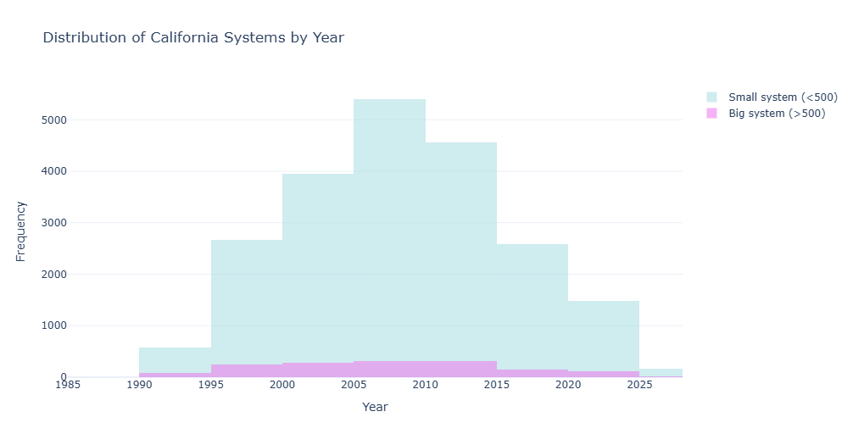
Figure 7, Distribution of California Systems by Year

Tennessee
Tennessee for this project was chosen as the representative state from EPA Region 4. Figure 8 shows the distribution of the systems in Tennessee by year. Tennessee has it’s maximum amount of small system violations of 404 in a five year period observed from 1990 to 1994, and has it’s maximum amount of large system violations in that same span with 50. Tennessee has a much older peak compared to other states in the dataset, which suggests that they have continually been able to maintain both their small water systems and their large water systems successfully as the years have progressed. 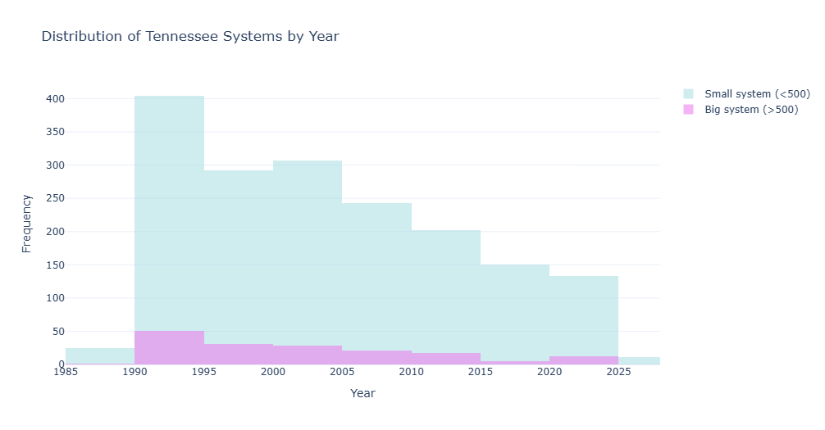
Figure 8, Distribution of Tennessee Systems by Year

Connecticut
Connecticut for this project was chosen as the representative state from EPA Region 1. Figure 9 shows the distribution of systems by year for Connecticut. Connecticut has it’s maximum amount of small system violations from 2000 to 2004 with 3963, and has its maximum amount of large system violations in the same span with 390. After this span the amount falls off, but doesn’t decline significantly from 2005 to 2025 for either the large or small systems.
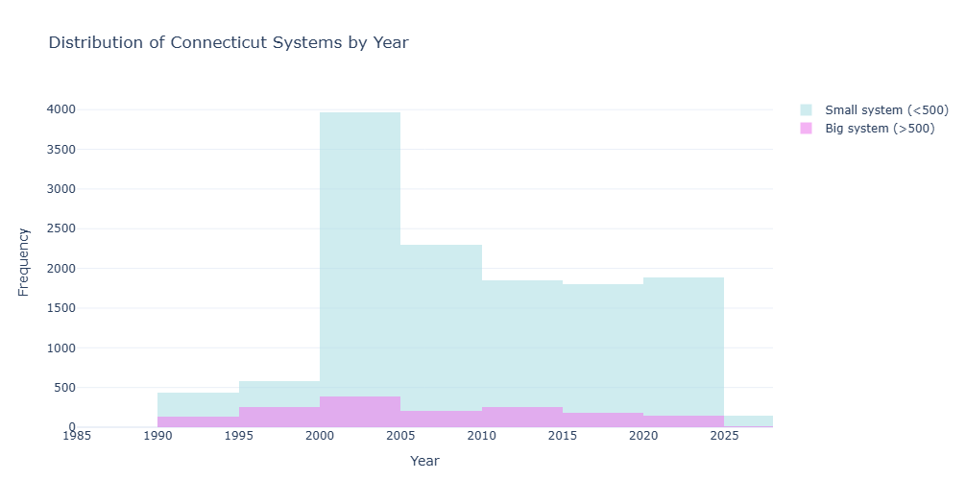
Figure 9, Distribution of Connecticut Systems by Year

Arkansas
Arkansas for this project was chosen as the representative state from EPA Region 6. Figure 10 shows the distribution of systems by year for Arkansas. Louisiana was initially selected by our project team as the representative state from region 6, but our project team had issues with how the data was recorded, so Arkansas was substituted as the other representative state. Arkansas had a very consistent distribution compared to other states, and had a much higher proportion of large system violations compared to the other observed states. Arkansas saw its max five year small system violation count from 2010 to 2014 of 837, and its max five year large system violation count from 2015-2019 of 233. The recent data still being high for Arkansas indicates that much more effort needs to be put into fixing water quality issues in the state.
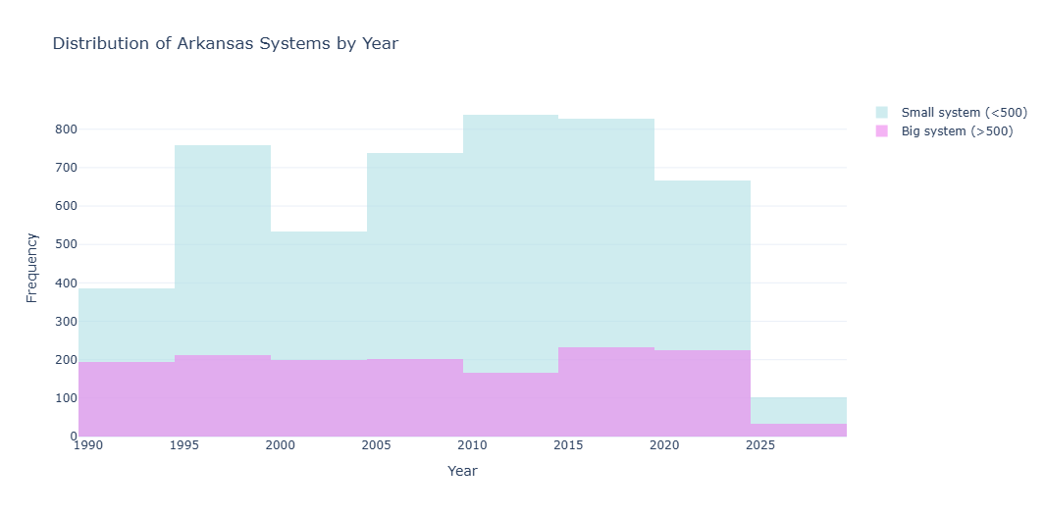
Figure 10, Distribution of Arkansas Systems by Year

Conclusion:
Our project team concluded that there is a significantly higher amount of small system violations compared to large system violations across all EPA region states that were investigated. TCR violations for most of the states have generally declined in recent years with both small systems and large systems. Further investigation might be necessary into what specific TCR violations are occurring with small vs large systems, and what the total count of small systems and large systems exist in the SWIDS database, which is outside the scope of the project.

References:
Environmental Protection Agency. (2026, February 12). Revised Total Coliform Rule and Total Coliform Rule. https://www.epa.gov/dwreginfo/revised-total-coliform-rule-and-total-coliform-rule

